**First install java and python in the system.**

**java**

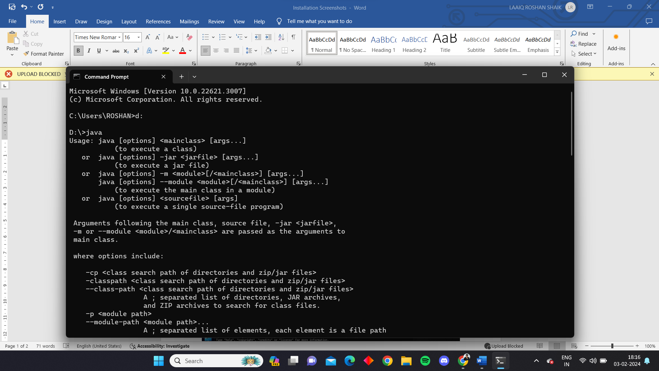

**python**

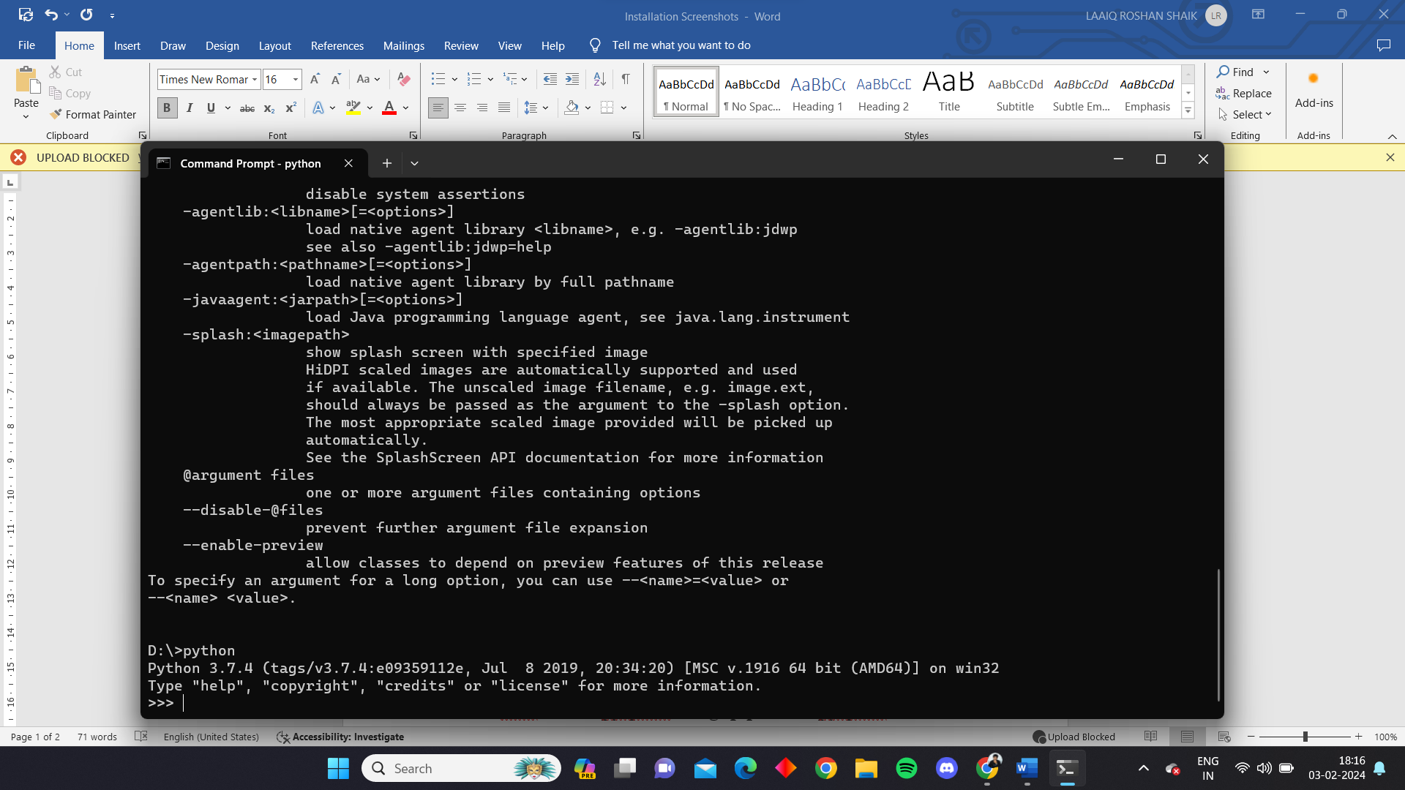

**Then download the apache spark file from** [**https://spark.apache.org/downloads.html**](https://spark.apache.org/downloads.html)

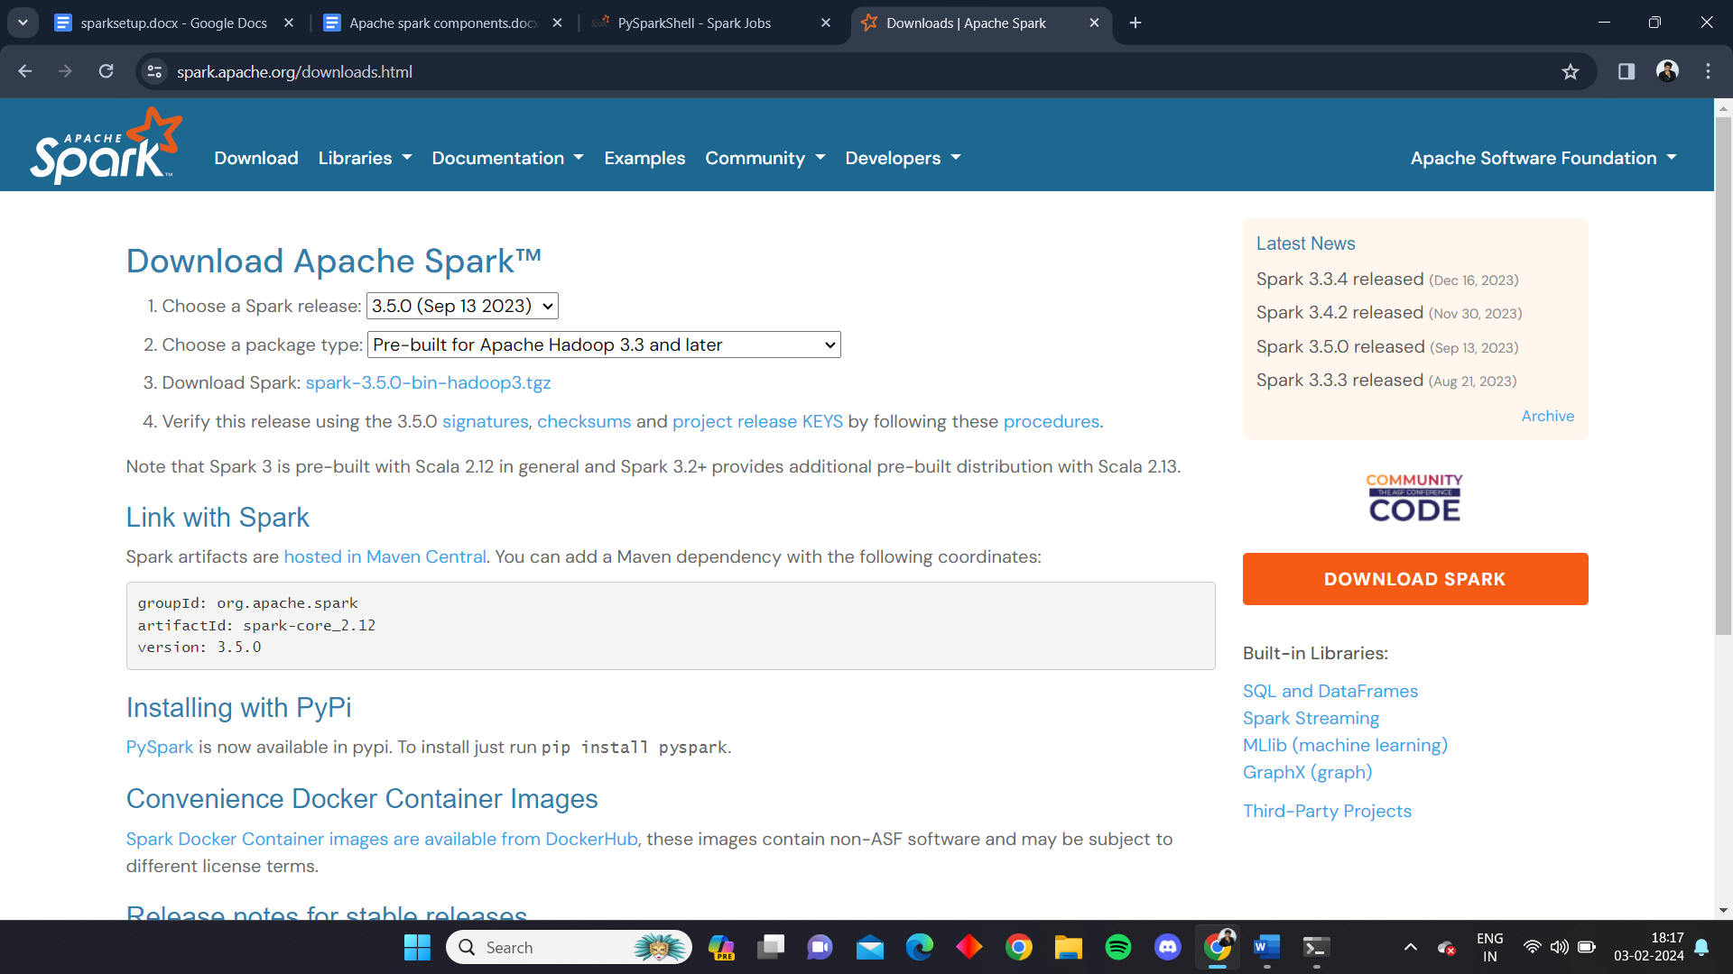

**Extract the file in a folder called spark**

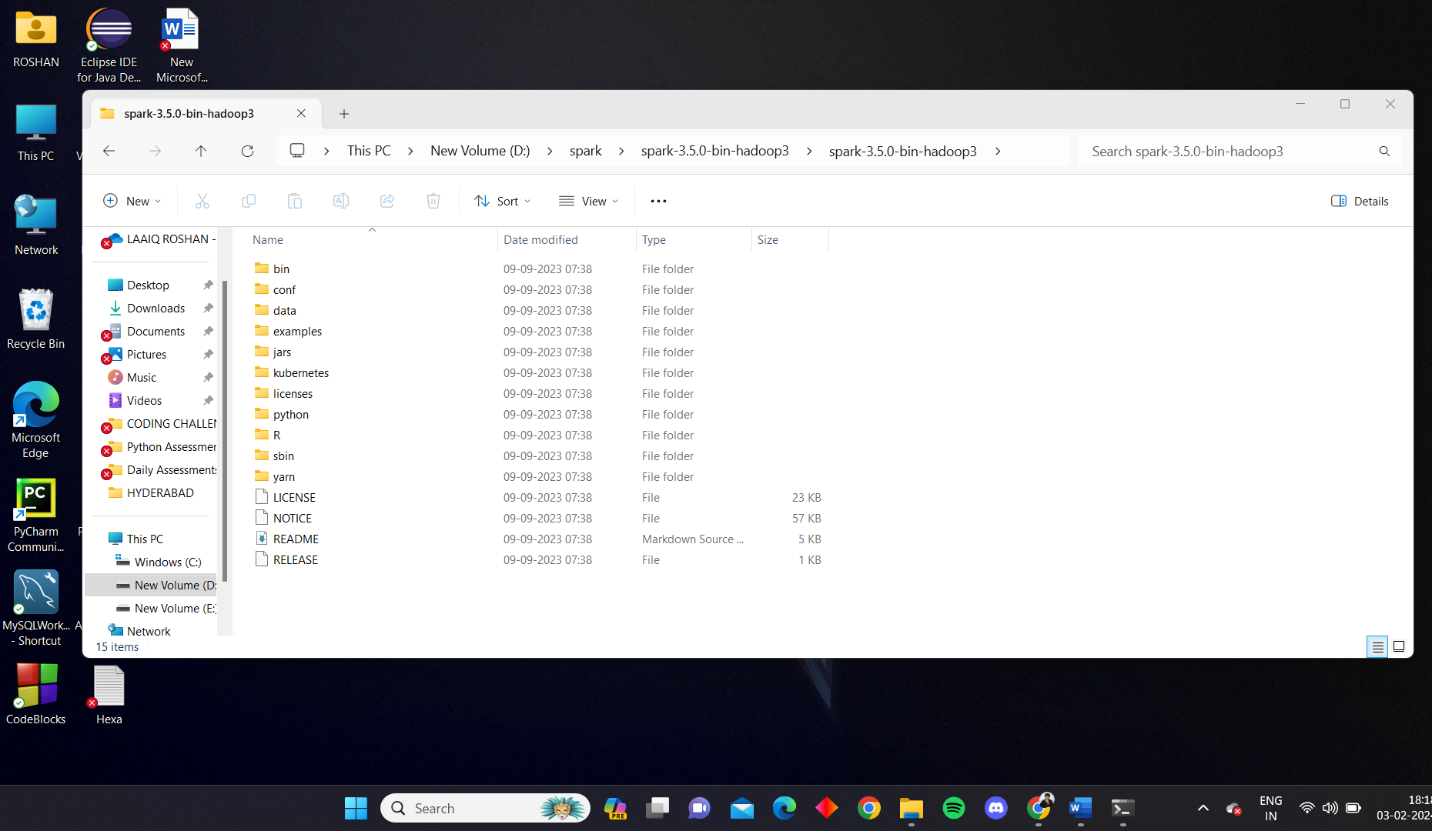

**Create environment variables for spark, pyspark and java**

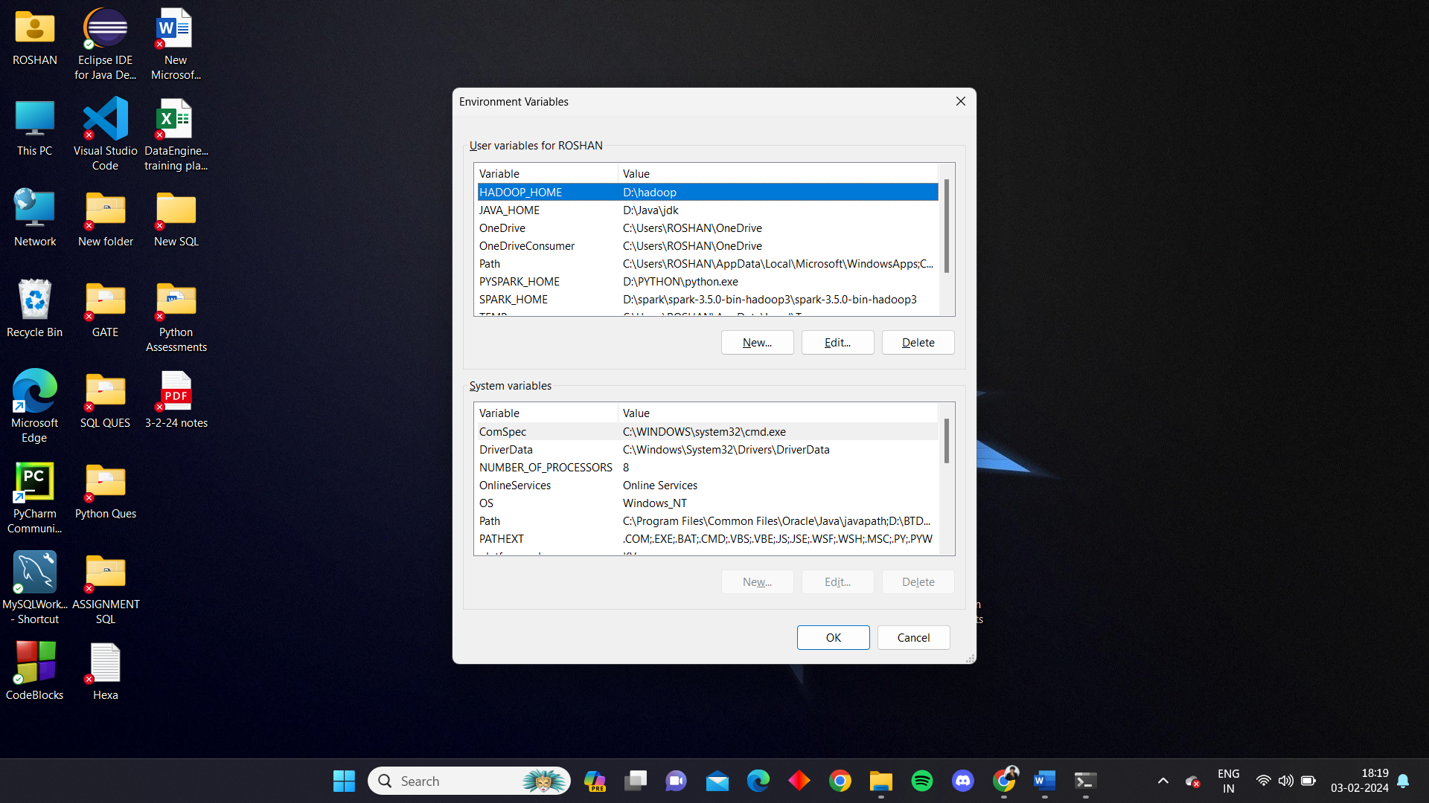

**Mention the paths of environment variables**

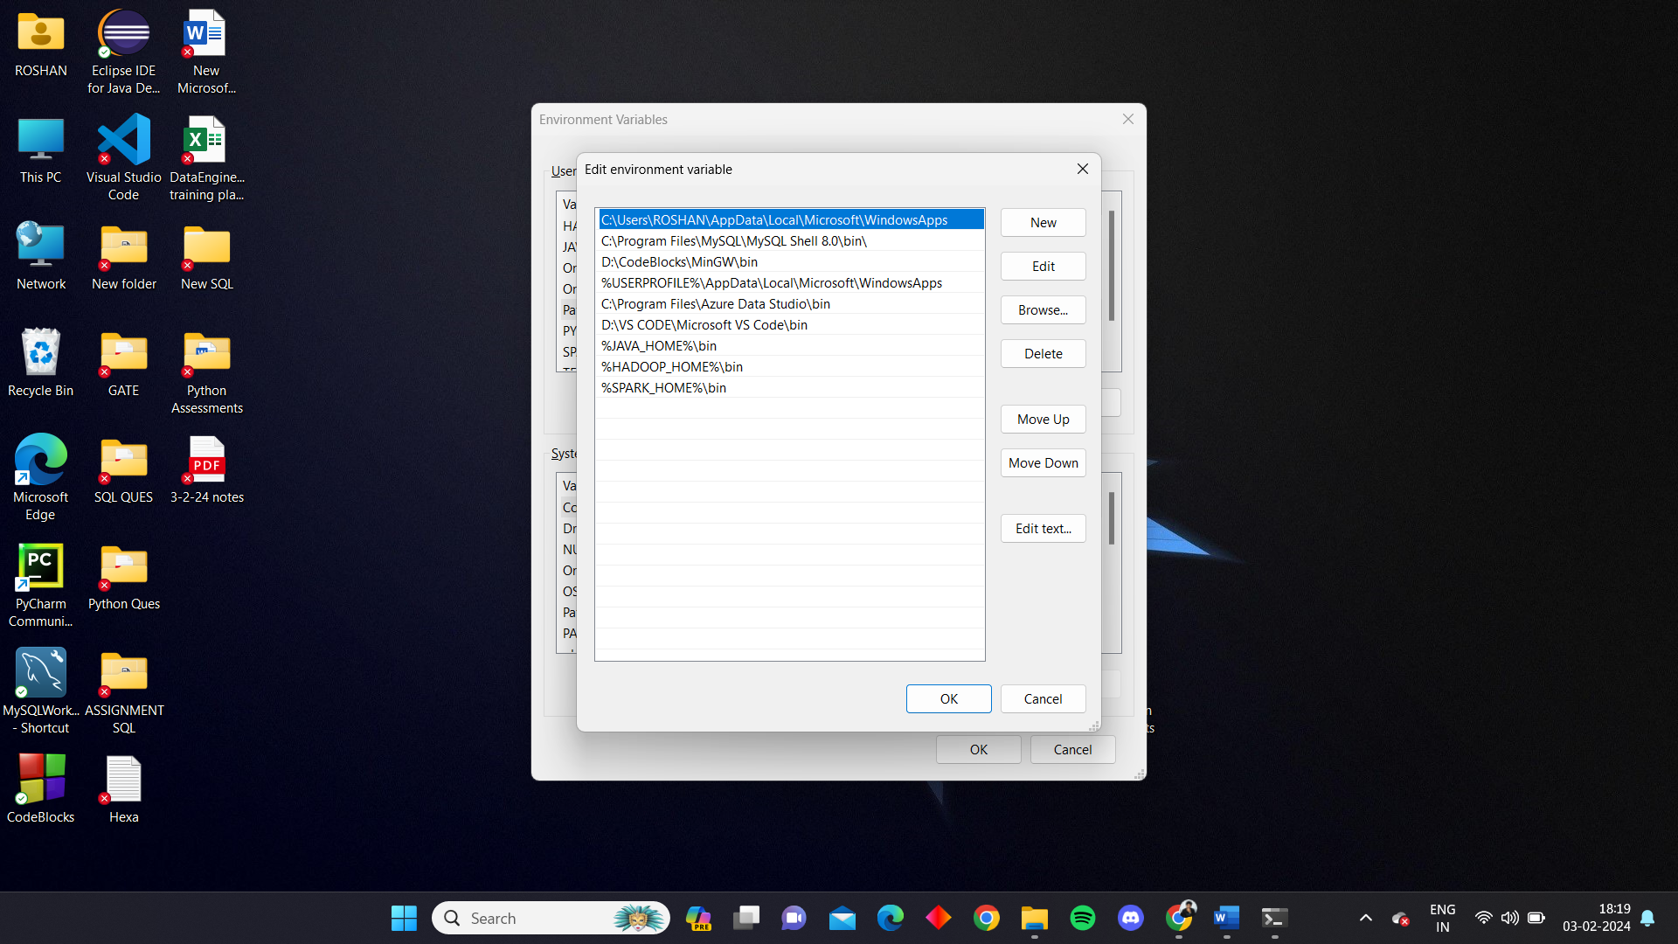

Then in cmd, install pyspark using ‘pip install pyspark’ command. Then type ‘pyspark’ to check for pyspark in the system.

**CMD**

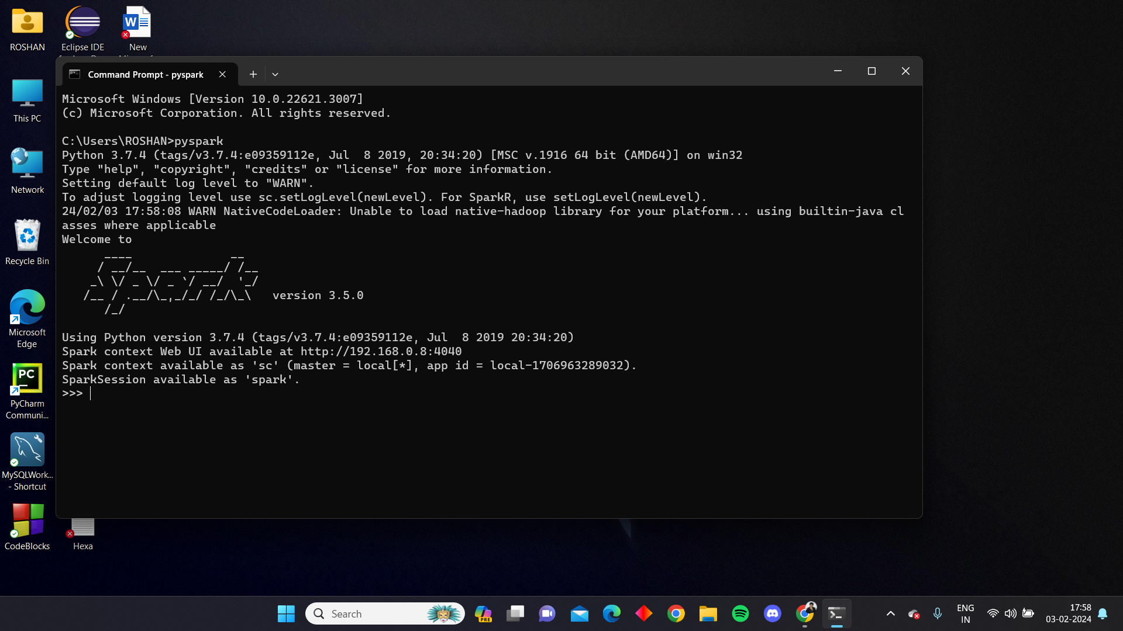

**Use the spark context web UI link to check the spark session**

